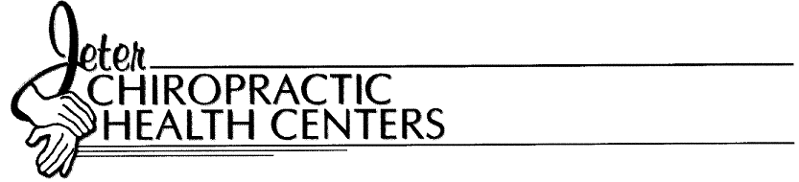

Informed Consent Form

I hereby request and consent to the performance of chiropractic adjustments and other chiropractic/medical procedures, including various modes of physical therapy and diagnostic x-rays by Mark E. Jeter, D.C.. This consent is also extended to other licensed chiropractic physicians, chiropractic assistants or licensed massage therapists, who now or in the future, are employed by, working with or are associated with this office.

I certify that I will have the opportunity to discuss, with Mark E. Jeter, D.C. and/or other office personnel, the nature and purpose of the care that is being provided. I understand that the results are not guaranteed. Further, I have been informed and understand, that as in the practice of any of the healing arts, in the practice of chiropractic, there are some risks to treatment including, but not limited to, fractures, disc injuries, strokes, dislocations and sprains. I also understand that the doctor, who has explained all these things to me, is not expected to be able to anticipate and explain all risks and complications. I will rely on the doctor to exercise appropriate judgment during the course of care, based on the facts known at this time, and in my best interest.

My signature below certifies that I have read, or have had read to me the above consent. I also certify that I have had the opportunity to ask questions and options to care have been explained. By signing this consent form, I agree to the care being provided to me for the entire course of treatment for my present condition(s) and for any future condition(s) for which I seek treatment.

___________________________ ____________________________
Patient’s name (please print) Witness’s name (please print)

___________________________ ____________________________
Patient’s signature Witness’s signature

___________________________ ____________________________
Date Date

___________________________ ____________________________
Patient’s representative (If patient is a Translated by
minor or physically/mentally impaired)

___________________________
Representative’s relationship to patient

Dr. Mark E. Jeter, D.C

